MA6

No. | INSTRUCTIONS FOR UPPER DIE INSPECTION |  | KEY POINTS / CONTACTS
1. | - Ensure that the die area is free from hazards by clearing out the die area before transporting the die to the workshop.  - You can not work under the die if it is not supported by the crane and the stands. |  | ENSURE PERSONNAL PROTECTIVE EQUIPMENT (PPE) IS WORN: -  1. Hard hat with chin strap  2. Steel cap boots  3. Gloves.  4. Torch.  5. Beware of sharp edges.
2. | Place die on rubbers evenly on the die area.  Refer to MAW 68 for die loading setting and turning. | 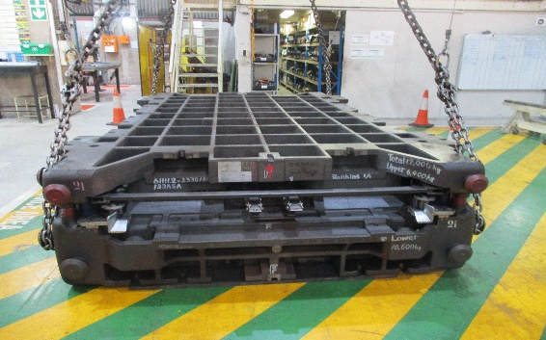
3. | Put up sign.  (DIE CHECK IN PROGRESS) | 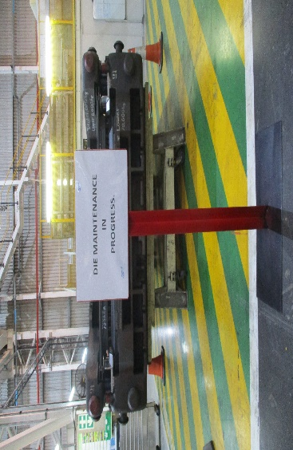 | .
4. | Open die with reference to MAW 68. | 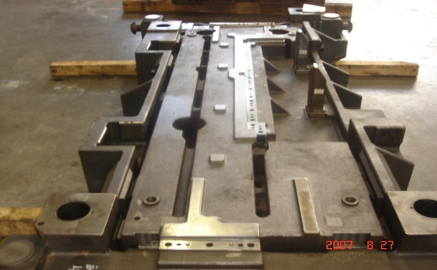

No. | INSTRUCTIONS |  | KEY POINTS / CONTACTS
5. | Place your lockout on crane remote, ensure the crane is supporting the die on the stand. Remove the crane remote battery and keep with you.
6. | CASTING:  Visually inspect for any cracks. | 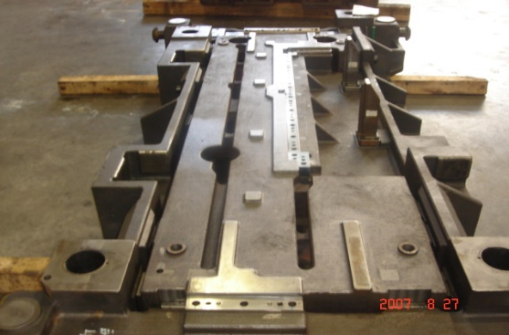
7. | BLADE:  Visually check for any chips  Tighten Bolts  Use an impact  Wrench (set @ No. 2) | 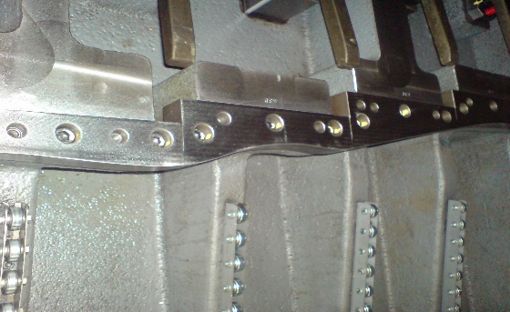 | 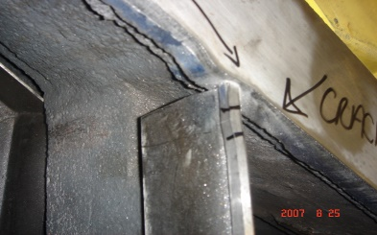  .  Example of a chip
8. | EJECT PIN:  Loosen housing  Check for proper performance  (push in, must return) | 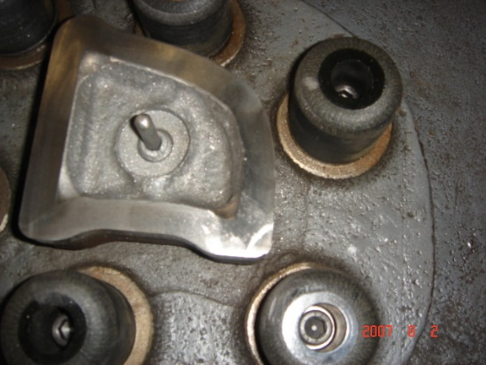 | 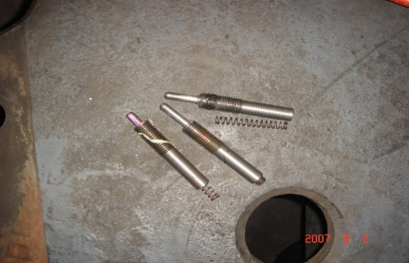  If found faulty, replace with lock tight.

No. | INSTRUCTIONS |  | KEY POINTS / CONTACTS
9. | SLIDE PLATES:  Check for scratch marks and wear.  Apply grease. | 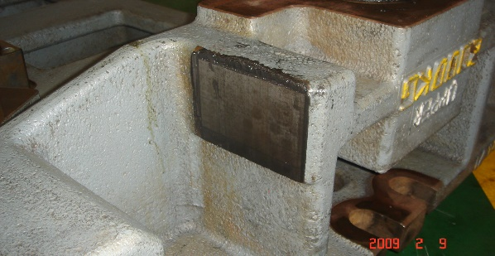 | Wipe away old grease before inspection. Use gloves.
10. | GUIDE POST BUSHES:  Check for scratch marks and wear. Check that the bushes are secured properly  Apply grease. | 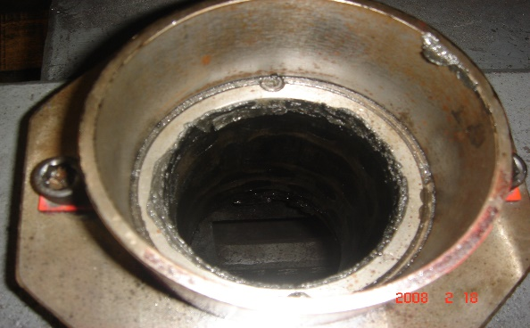 | Wipe away old grease before inspection. Use a torch.
11. | LIFTER RUBBERS:  Tighten mounting bolts  Check rubbers for cracks | 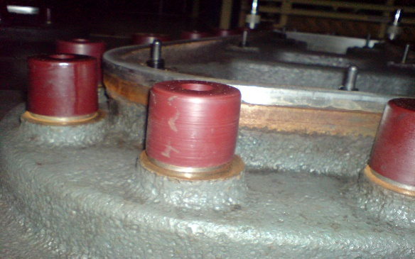 | 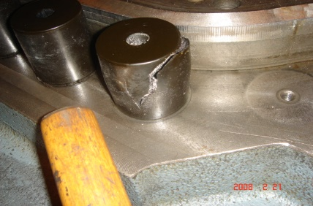  .  Example of damaged rubber
12. | NITROGEN GAS:  Check that the gauge shows correct pressure, 1500 MPA.  Use soap water to check for leaks.  Applicable only on DIE 1,18,19 and 9 | 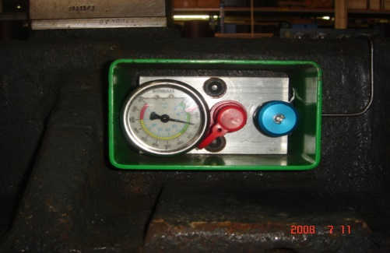 | 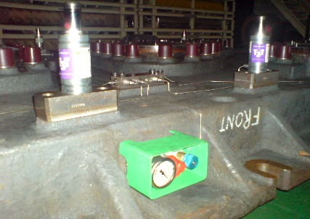  Check all connectors for leaks

No. | INSTRUCTIONS FOR LOWER DIE INSPECTION |  | KEY POINTS / CONTACTS
13. | CASTING:  Visually inspect for any cracks | 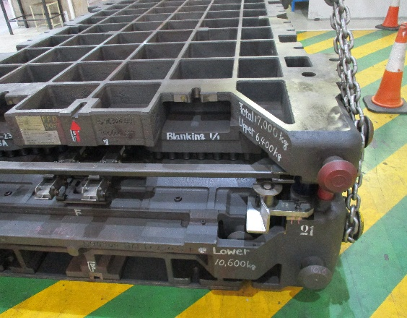 | Check that the 30mm bolts that holds the lower die to the 300mm base are all tight.  Die 18 and 19 only
14. | BLADE:  Visually check for any chips  Tighten Bolts  Use an impact  Wrench (set @ No. 2) | 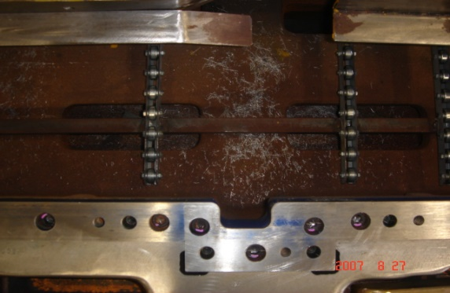 | 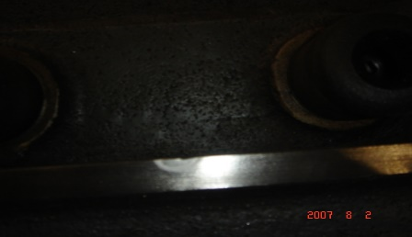  Example of a chip
15. | GUIDE POSTS  Check for scratch marks  Apply grease | 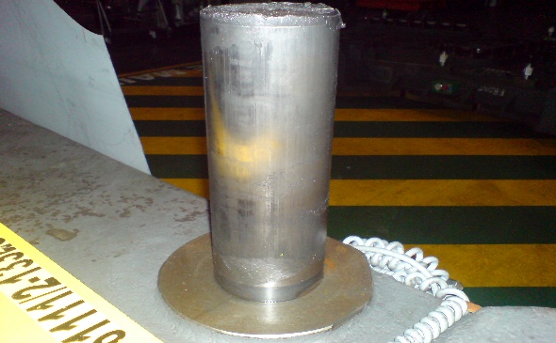 | Wipe away old grease before inspection. Use gloves.
16. | LIFTER  Check for skid bar scratch marks  Tighten bolts  Check springs | 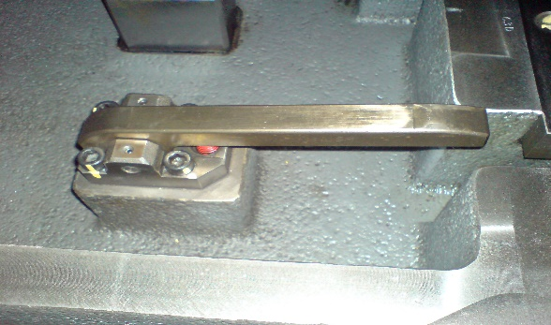 | Press down the lifter and check that it returns to its up position. If it does not, the spring may be broken
17. | GUIDE ROLLER  Check that bearings spin freely  Tighten mounting bolts | 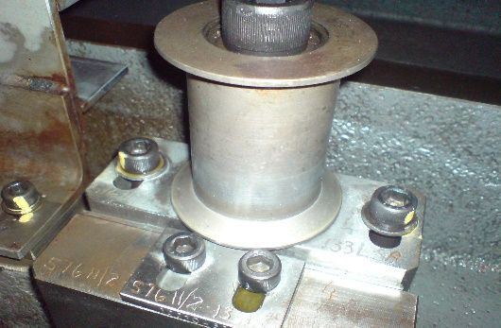
18. | SLIDE PLATES:  Check for scratch marks  Apply grease | 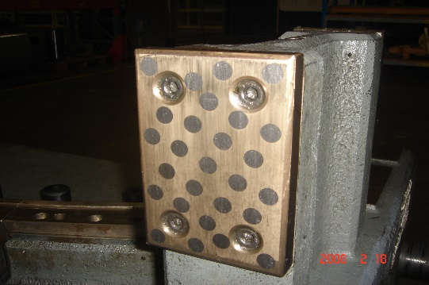 | Wipe away old grease before inspection. Use gloves.
19. | FRONT GUIDE  Check for scratch marks  Tighten mounting bolts | 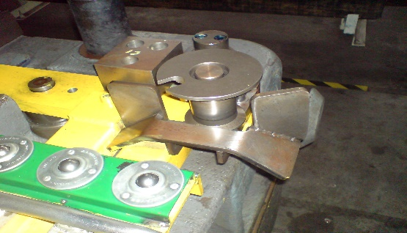 | Spin to check that the bearings are free.
20. | CHUTES  Check for deformation and damage  Tighten mounting bolts | 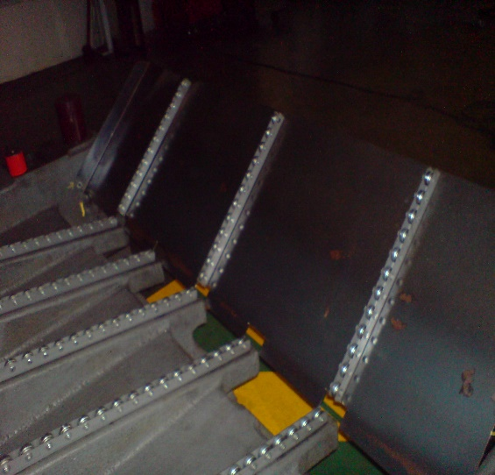 | Ensure all rollers are working correctly.
21. | INSIDE DIE  Check and clean | 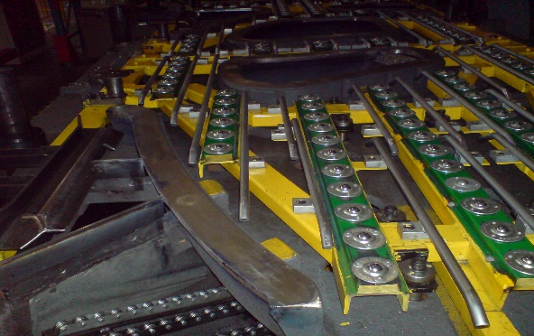 | Check for any scrap, rags, bolts or tools that may have been left behind during maintenance. Use a torch.
22. | UNDER DIE | Place die on tressels and remove any burrs underneath the die. | NB: Do not remove crane slings when working under the die.
23. | Close the die  With reference to MAW 68. | 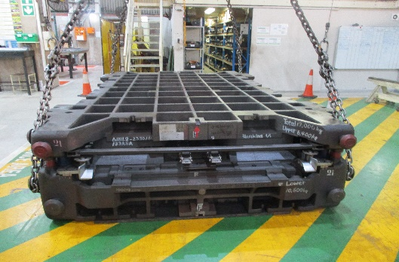
24. | Clean up die area after die service,  (PROPER 5S) | 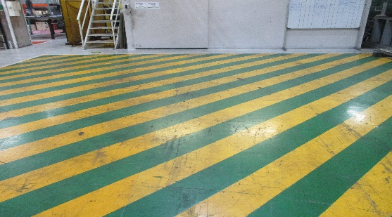 | Ensure that there is no tools or items left behind when the inspection is complete
25. | Place back battery and return the remote to the remote station or operator and remove sign. | 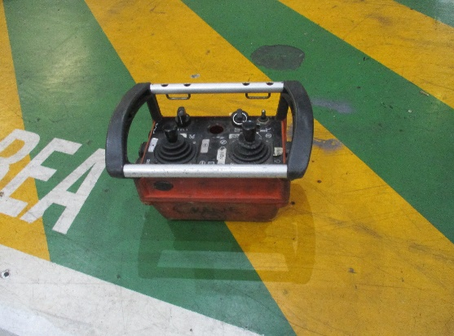
26. | Update maintenance connection and attach pictures of findings. | 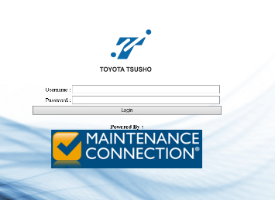 | All findings and work done must be recorded on maintenance connection

